Notes and task on AWS system manager-01
AWS Systems Manager (SSM) is a service from Amazon Web Services that helps you manage, monitor, and automate operations for your infrastructure—especially EC2 instances, on-prem servers, and other cloud resources—at scale.
Think of it as a central control hub for your servers and resources.

🔧 What you can do with AWS Systems Manager
Here are the key capabilities:
1. Run commands remotely (no SSH needed)
- Use Run Command to execute scripts or commands on multiple servers at once
- No need to open SSH ports or manage keys
2. Patch management
- Automatically apply OS updates and security patches
- Helps keep systems compliant
3. Configuration management
- Maintain consistent system configurations using State Manager
4. Secure access (Session Manager)
- Connect to EC2 instances directly from AWS console
- No SSH, no bastion host, no inbound ports required
5. Automation
- Automate routine tasks like:
  - Restarting instances
  - Creating AMIs
  - Fixing common issues
6. Inventory & compliance
- Collect metadata about your instances (installed software, configs)
- Track compliance against policies

🧠 How it works (simple view)
- You install an SSM Agent on your instances (often pre-installed on AWS AMIs)
- The agent communicates with AWS Systems Manager
- You control everything from the AWS console, CLI, or APIs

🧩 Example use case
Instead of logging into 50 servers to update packages:
- Use Systems Manager → Run Command
- Execute a patch/update command across all servers at once

🚀 Why it’s useful
- Improves security (no open SSH ports)
- Saves time with automation
- Simplifies large-scale management
- Provides centralized visibility
Created a new role in IAM service with the following policy attaching to it:
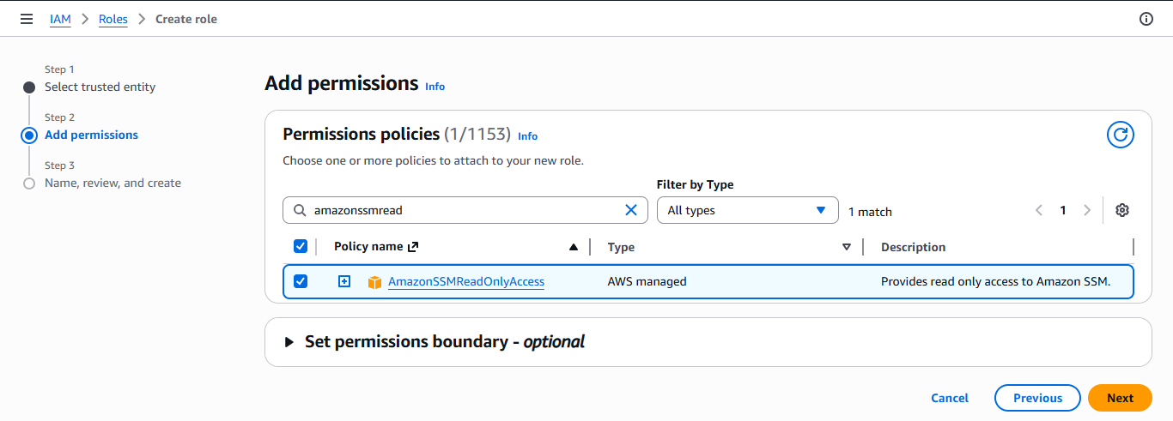
Then provided the Amazon ssm read only access policy to it.
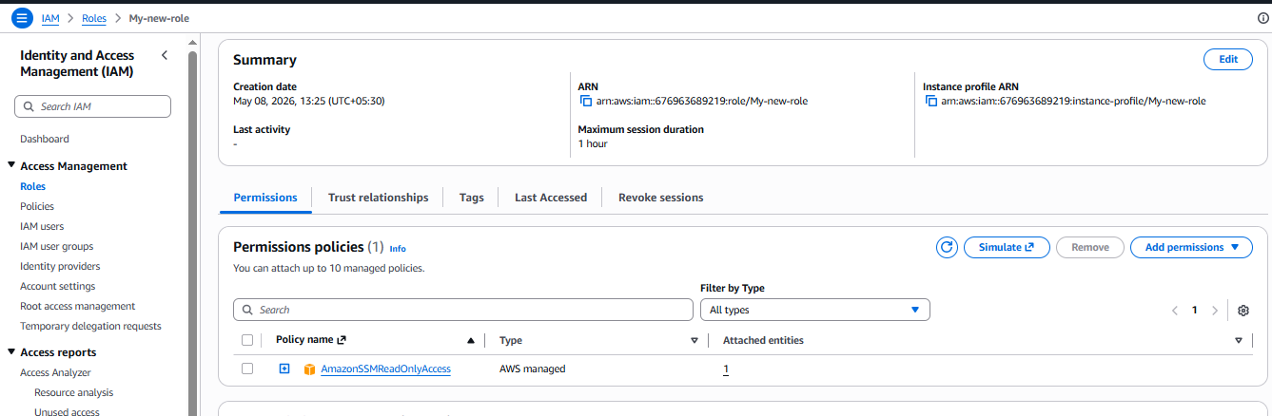
Created a new VPC and then a new subnet as well then created a new instance:
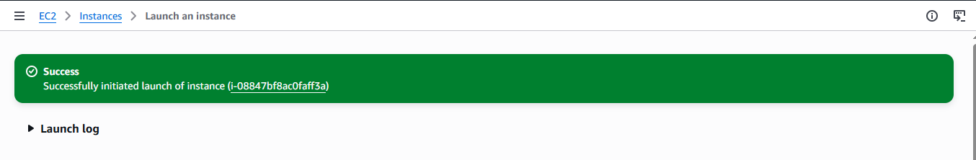
Created a new IGW and then route table and then connected to instance:
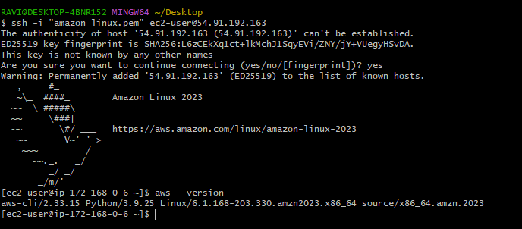
Created a new parameter in system manager:
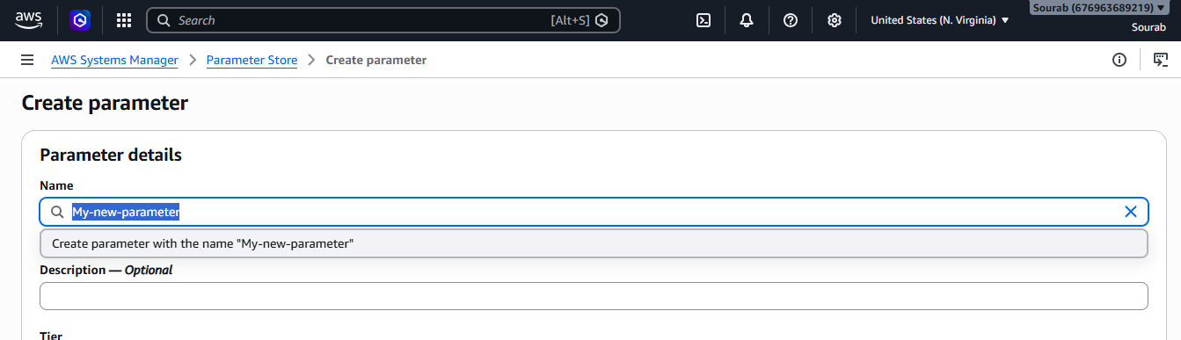
Value is Sourab@800
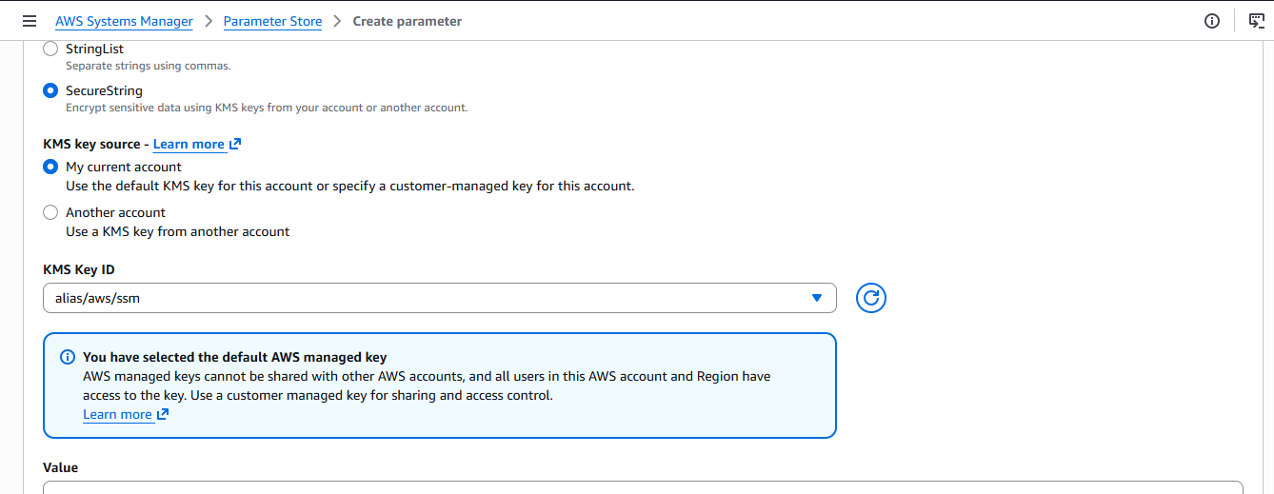
Created a new parameter in the system manager steps:
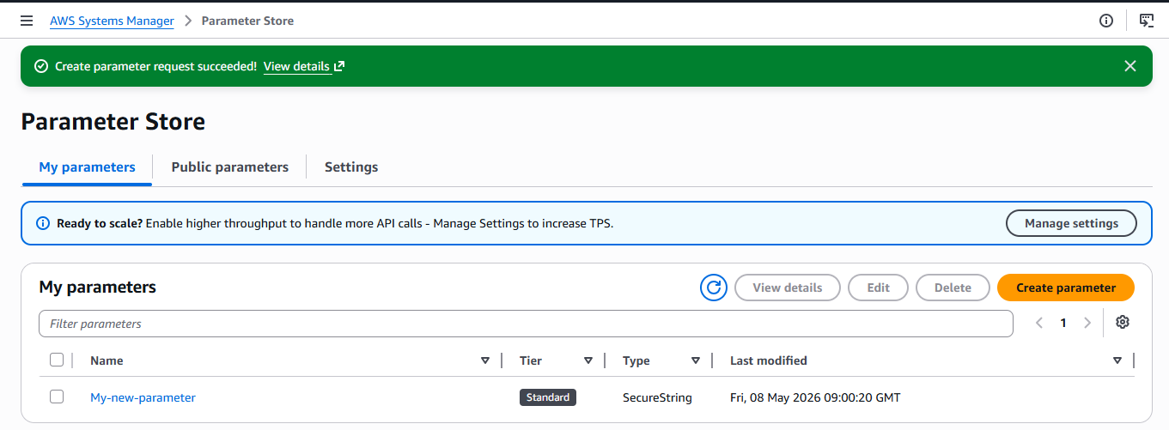
Then followed the below command in CLI:
aws ssm get-parameter \
--name "/My-new-parameter" \
--with-decryption
Then got this result:
